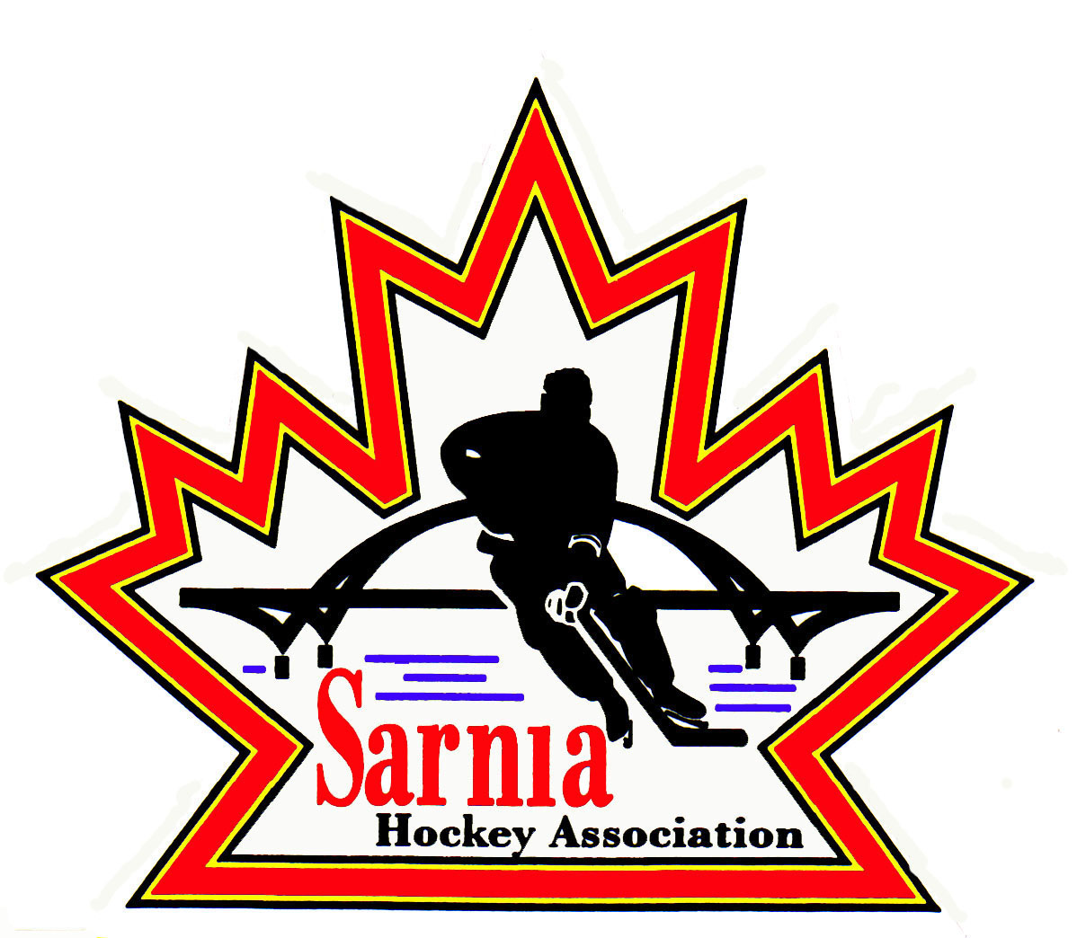

Sarnia Hockey Association

Minutes | Date: AUGUST 12, 2025 | time 7:00 pm

Meeting called by | Paul Walsh, President
Type of meeting | Regular
Secretary | Kelly Lane, Recording Secretary

Welcome | Paul Walsh, President, and meeting Chair welcomed everyone and called the meeting to order at 7:06 pm.

ATTENDANCE | Heather Amaral, Jacquie Beasley, Jerry Bernardo, Emily Brown, Geoff Dale, Paul Douglass, Chuck Ewart, Jeff Fogal, Terry Gray, Ryan Gruntz, Kelly Lane, Cris LaPointe, Linda Lauzon, David Penner, John Ritchie, Carrie Ritchie, Wayne Scarrow, Tim Turner, Barb Walsh, Paul Walsh  Regrets: Andrew Beasley, Alister Brown, Ian Dunn, Pat Forbes, Dan Hunt, Bonny Marcy, John Mellor, Kyle Mellor, Blake Morrison, Nick Mroczek, Ted Pendle

ACCEPTANCE OF MINUTES | MOTION #250812-001  “That the Minutes from July 23, 2025, be accepted as presented.” (C. Ritchie/J. Ritchie )  Carried with one amendment  Add Geoff Dale as seconder in adjournment on last meeting.

TREASURER’S REPORT | Se  MOTION #250812-002  “That the financial Report be accepted as presented.” (Lauzon/Dale)  Carried  - Financial report as of 31 July was sent out to the Board via email.  - $240,000 in player registration attributed to payment plans, Rec registration etc. There is still money outstanding.  - We will hit our registration target, so there are no concerns with the budget.  - Admin expense of $3300 is for an invoice from Sportzhead regarding our website.  - Financial audit is still outstanding.  - Treasurer will send reminders to parents that have significant outstanding registration fee balances which are due September 1. Most are on payment plans.  - If there are any issues with outstanding payments for rep players, the Rep Directors will be notified.  - There are some requests coming in for assistance for rec players.  STING ASSIST GRANT:  - Every spring we submit a grant request, and the ask is typically $10,000. This goes towards ice costs. We received $8000. We are waiting for the photo in order to post a thank you on our social media.  COUSI GOLF TOURNAMENT:  - The golf tournament occurred on July 26. They didn’t have as many golfers this year. We did have a group from Sarnia Hockey that played in the tournament. The Cousi group was happy to have the support, and they raised $34,000.  - For this year, a small stipend will be given to Sarnia Lady Sting for goalie development. We expect $6,600 will go to Sarnia Lady Sting.  - We will likely get $32,000. $21,500 is earmarked for goalie support (shared ice practices for Rec, Rep and select), $3000 to goalie equipment for Rec and $10,275 for player subsidy for Rec players. Goalies that are outside of the loaner program were allowed a $100 subsidy for equipment and this year this is being increased to $150. There will be a contingency of 10%.  - Cousi is thrilled with how the tournament went and they are excited that they had more sponsors than last, and they believe it will grow year after year.  - Cousi is also sponsoring a U18 Rec team. They want the Cousi logo on goalie jerseys as well.  MEETING WITH SARNIA STING ORGANIZATION:  - We had our annual mid-summer meeting with Jake Bourrie and Val Gotelaer from the Sarnia Sting to reconfirm our partnership. There will be flex passes again this season. In Rep it is built in and the passes will be handed out through the teams.  - For Rec, there will be a process where they can request one flex pass for each player and volunteer. When they receive the code, they pay the Sting directly for the pass.  - The Sting are also sponsoring U9 and below Player of the Game pucks. We get $1000 sponsorship money for that initiative.  - Sarnia Hockey Night at the Hive where we celebrate our Rec league sponsors will be November 9. There are activities before and during the game. We are sharing that date with Remembrance Day ceremonies. It is a Sunday afternoon game.  - Cousi people will be invited to the suite along with our sponsors.

BILLS TO BE PAID | MOTION #250812-003  “That the bills be paid as presented.” (E. Brown/J. Ritchie)  Carried  - No concerns that U18 BB will be fielding a team. There is a healthy registration. There will be trickle down from AAA as well.
  Recipient | Expense | AMOUNT
  City of Sarnia  U18 BB Coach | Summer meeting room rentals and Select interviews  Tournament registration reimbursement – goes against the teams loan | $ 694.95  $ 6,439.50

REC EQUIPMENT DIRECTOR | - Report was read out by meeting chair in Rec Equipment Director’s absence.  JERSEYS  - Jerseys for U13 and above are confirmed with Planet Stitch and just waiting on final number of teams in U18/21 and some sponsor confirmations.  - Jerseys are in hand for U11.  - Order is in with Team Outfitters for U9 and jerseys are going into production this week. Just waiting on sponsor to review proofs.  - Tim Bits (first time players) will receive their jerseys at Tim Hortons on London Road – date and time to be determined.  STORAGE:  - Cris LaPointe is assisting with discussion regarding PASA Storage.  - Cris provided an update on storage at PASA:  - They are moving cages we already have and building new ones. All cages are moving to storage in PASA 1. Wooden shelving was damaged due to flooding. We don’t know the bill for this but will be split between 3 organizations. We are getting 3 cages built. Ken Ayers is doing the construction.  - Checking on lockers at Clearwater Arena and getting gear in when they are available.  - We are in good shape for equipment. Waiting on confirmation for Cousi funding which he now has.  - We will increase amount for sponsorship for division that wants additional logos on shirts. Rec Sponsorship Director and Treasurer will finalize that.

RECREATIONAL  REGISTRAR | REGISTRATION NUMBERS:  FOUNDATIONS SPOTS REMAINING:  U6 - Foundations - 98 registered – 3 on wait list  U7 - Foundations - 29 registered – 2 on wait list  U8 - Foundations - 9 registered  U9 - Foundations - 3 registered  U10 - Foundations - 5 registered  U11 - Foundations - 1 registered  Total Players registered Rep/MD/Foundations/Rec. - 1131 participants  - Discussion re U9 number of teams.  - U18 will be 8 teams.
  DIVISION | AUG 6, 2024 | AUG 8, 2025 | REP 2025
  Foundations | 127 | 150 | U8 MD 27
  U7 | 93 | 101 17 remaining | U9 MD 46
  U9 | 159 | 129 15 remaining | U10-U16 AA 119
  U11 | 152 | 103 33 remaining | U10-U16 BB 119
  U13 | 171 | 102 34 remaining | U18 AA 32
  U15 | 160 | 81 27 remaining | U18 BB 16
  U16-U18 | 155 | 106 34 remaining
  U21 | 16 |  | TOTAL REP and MD/REP
   |  |  | (TRYOUTS)
   | TOTAL 1033 | TOTAL 622 | 359

VICE-PRESIDENT REPRESENTATIVE TEAMS | - A Trainer reached out from our U14BB team wanting us to implement the Stop the Bleed program.  - It is a National Awareness program which allows public and first responders to help before professional medical personnel arrive.  - Would be free for the program and $75 for travel costs to Sarnia.  - Each participant would receive a certificate.  - This program was brought up at Rep Council. Elgin Middlesex participated in this program last year.  - Level 1 Trainer’s Program is online course and is basically risk management.  - Alliance supports the Stop the Bleed program.  - Alliance asked each Association how many Level 1 and Level 2 trainers we have. We only have Level 1 trainers. For Level 2, trainers need Standard or Advanced First Aid. If you are a medical professional, they will accept that in lieu of a First Aid program. Cost is an additional $8 to get Level 2.  - Discussion about how our Association should require Level 2 Trainers.  - Stop the Bleed teaches application of a tourniquet.  - We will ask people who already have current First Aid certification to upgrade to Level 2 Trainers. A lot of people already have it through their workplace.  - First Aid certification is good for 3 years.  MOTION #250812-003  “That SHA provide opportunity for “Stop the Bleed” training program for this season with a plan for mandatory Level 2 Trainers for the 2026/27 season.” (E. Brown/Ewart)  Carried  - We will set up a date for the Stop the Bleed program and it will be mandatory for all SHA Trainers.

ICE DIRECTOR | - Scheduling of regular season games.  - Started A scheduling and waiting on St. Thomas and London.  - BB scheduling will be starting in a couple of weeks.  - Ice Scheduler will send info to SHA Referee Director for ref scheduling.  - Tryouts – U8 will start on Sept 6.  - AAA U18 tryouts are starting Aug 18-24. U18 A tryouts will be after AAA (August 25), but the ice rate is not subsidized ($305 per hour) but the cost of tryouts should cover this off.  - Need to check with Alliance whether exhibition games can occur that week.  - Sarnia Girls hockey is doing their one-day celebration again this year and want us to give up our ice on October 25. They gave us ice on Oct 26 for U7/8 rec at 11 am.  - Evaluation skates for U6/7 will be Sept 13 at Clearwater Blue.  - Sept 14 will be U8/9 Evaluation skates.  - Rec will start Sept 29 with the first games starting the following week.  - U18 Rec can start on Oct 5. Need to check that U18 jerseys will be completed by that date.  - Rep ice will be sporadic times for first few weeks in September.

SKILLS DIRECTOR | - Prep skates are Sept 3,4 and 5 for U8, U9.  - Last year cost was $120.  - Goalies will receive skill session at prep skates.  - Darren Rogers can do all of the prep skates.  - Kaden Fulcher will be doing goalie sessions.  - 27 registered for U8 Prep Skates.  - 46 registered for U9 Tier 1 and 2  - Prep Skates will likely sell out quickly for U8 and 9 due to lack of ice over the summer.  - Skills Director will work with Darren Rogers and Kaden Fulcher regarding maximum numbers.  - On the flyer we are listing 54 spots, but we can confirm this.  - Goalie cost is $50.  - This can go live for registration as of August 13.  - Info can be posted on our social media.

NEW BUSINESS | NEXT MEETING:  - Next meeting is Tuesday, September 2, 2025. Location to be determined.

adjournment | MOTION #250812-004  “That the meeting be adjourned.” (Douglass/Brown)  Carried

Paul Walsh Kelly Lane
President Secretary

